Station 1: Shapes, Polarity, and Solubility
One way to test if a molecule is polar or non-polar is to see how it mixes with other solvents. Use the
following to predict the polarity of the provided molecules and then test your prediction by determining
its miscibility. You do not need large amounts of the solvents to be able to determine their miscibility.
Molecules:
Water – H₂O
Methanol – CH₃OH
Acetone – (CH₃)₂CO
Hexanes – C₆H₁₄
Dichloromethane – CH₂Cl₂
- Complete the following table to determine the miscibility of the molecules. Record “yes” if the two
molecules are miscible and “no” if they are not.

 | H₂O | CH₃OH | (CH₃)₂CO | C₆H₁₄ | CH₂Cl₂
H₂O | -- | Yes | Yes | no | no
CH₃OH | Yes | -- | Yes | no | no
(CH₃)₂CO | Yes | Yes | -- | Yes | no
C₆H₁₄ | no | no | no | -- | Yes
CH₂Cl₂ | no | yes | Yes | Yes | --

- What patterns do you notice between the polarity of molecules and their miscibility? Support your
answer with evidence
Molecules with polar bonds only are miscible for example acetone and methanol both have the polar bonds which enables them to be miscible.
- Using this information, explain what you believe “like dissolves like” means in the context of polarity
and miscibility.
“like dissolve like “means that polar solvents dissolves in other polar solvent only but not non-polar solvent, therefore implying that polar solvents are miscible.
Station 2: Shapes and Evaporation
In this part of the experiment you want to determine which of the five molecules: acetone (CH3CO2H),
methanol (CH3OH), hexanes (C6H14), dichloromethane (CH2Cl2), and water (H2O) evaporates the fastest. To determine the rate of evaporation, wrap a piece of filter paper around the end of a thermometer and
submerge it into the solution of choice. After you have an initial temperature reading, remove the
thermometer and position it so that the solution can evaporate from the filter paper. Record the
temperature every 30 seconds until the temperature stabilizes (approximately 9 minutes).
- Data from the experiment
Time | Acetone | Methanol | Hexanes | Dichloromethane | Water

- Explain the relationship between the intermolecular forces (attractive forces) and the rate of
evaporation.

- Predict the order of the rate of evaporation for the following molecules. #1 will have the fastest
rate of evaporation and #4 will have the slowest rate of evaporation. Explain your reasoning in 2-
4 sentences.

Station 3: Testing Polarity
At this station you will predict and test your hypothesis about the polarity of molecules. To test the
polarity you will statically charge saran wrap with a towel. Then measure the amount of deflection that
the static charge causes to a stream of the liquid dispensed from a burette.
- Complete the following table to predict the polarity of the given molecules.
Molecule | Electron geometry | Molecular geometry | polarity
H₂O | Trigonal planar | Bent | Polar
CH₃OH | Tetrahedral | Bent | Polar
(CH₃)₂CO | Dihedral | Trigonal planar | Polar
C₆H₁₄ | Tetrahedral | Tetrahedral | Non - polar
CH₂Cl₂ | Tetrahedral | Trigonal pyramidal | Moderately polar

- Rank the molecules in order of increasing deflection caused by the statically charged rod.
- Water
- Methanol
- Acetone
- Dichloromethane
- Hexanes
- In 2-3 sentences explain how to the shape of the molecule is related to the amount of deflection
caused by the statically charged rod.

Static charges are charges at rest. When a rod is charged by static charges, it possesses charges at rest. Since polar solvents half partial charges and from the low of electrostatics which states that like charges repel and unlike charges attract. The negative charges in the molecular structure of the polar solvent and the negative charges in the charged rod will repel causing the shape of the molecule.

Station 4: Shapes and Physical Properties
Below is a series of molecules with data about their physical properties (boiling point, viscosity, vapor
pressure, molecular weight, etc.). Use this data to answer questions about the molecules.
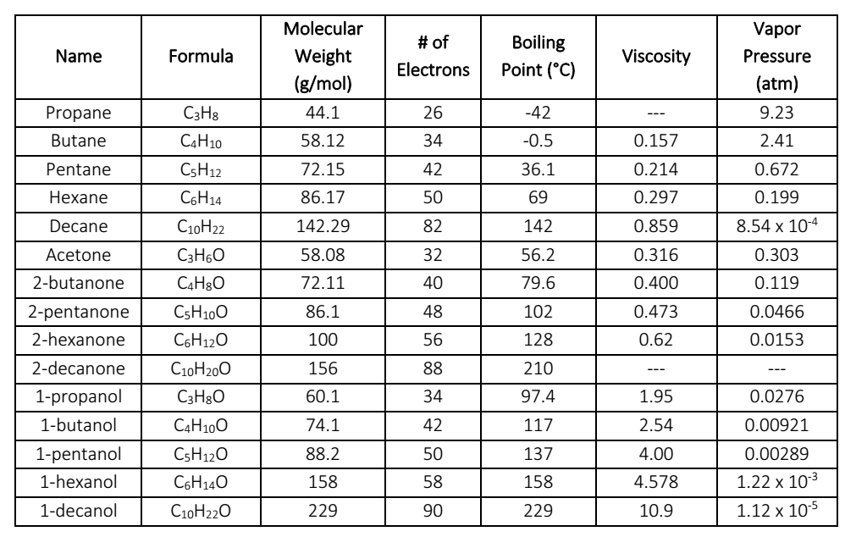
- Complete the following table for each of the molecules. NOTE: These are organic molecules so
the naming and the Lewis structure are a bit more complicated than you’ve seen before. Use the
internet to help you determine and check the Lewis structure.
Name | Lewis Structure | Polar or Non-Polar | ALL  Intermolecular  Forces. Write the  strongest force  present.
Propane  C3H8 |  | Non -polar | Van der Waals forces
Butane  C4H10 | 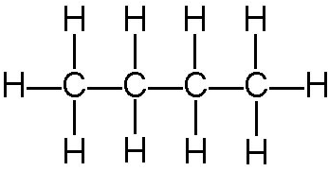 | Non – polar | Induced - dipole
Pentane  C5H12 | 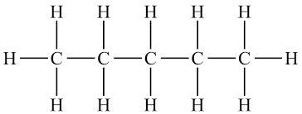 | Non - polar | Induced - dipole induced dipole forces
Hexane  C6H14 | 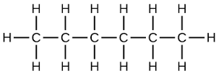 | Non-polar | Induced - dipole induced dipole forces
Decane  C10H22 | 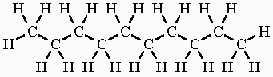 | Non - polar | Van der Waals forces
Acetone  C3H6O | 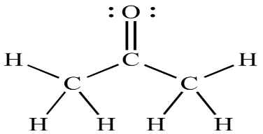 | Polar | dipole-dipole interactions and van der Waals forces.
2-butanone  C4H8O | 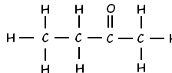 | Non- polar | Van der Waals forces and dipole- pole forces
2-pentanone  C5H10O | 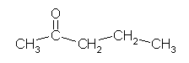 | Non - polar | Van der Waals forces and dipole- pole forces
2-hexanone  C6H12O | 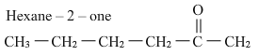 | Non-polar | Van der Waals forces and dipole- pole forces
2-decanone  C10H20O | 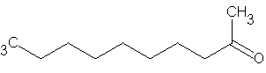 | Non - polar | Van der Waals forces and dipole- pole forces
1-propanol  C3H8O | 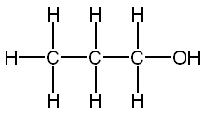 | Polar | Van der Waals forces, dipole- pole forces and hydrogen bond
1-butanol  C4H10O | 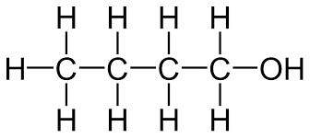 | Polar | Hydrogen bond
1-pentanol  C5H12O | 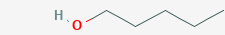 | Polar group on end and non – polar group on the end | Hydrogen bonds
1-hexanol  C6H14O | 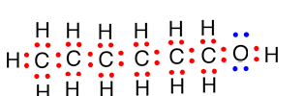 | Non - polar | Hydrogen bond and van der Waals forces
1-decanol  C10H22O | 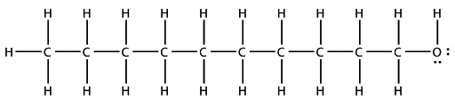 | Non - polar | Hydrogen bond and van der Waals forces

- What is the relationship between the strength of the attractive forces between molecules and
the boiling point? Provide an explanation for why you believe this trend exists.
Molecules with straight hydrocarbon structure have high attractive force and low boiling point, this is because the carbon atoms have double bonds creating a high force of attraction.
- What is the relationship between the strength of the attractive forces between molecules and its
viscosity? Provide an explanation for why you believe this trend exists.
The strength of the attractive force increases between molecules causing an increase in viscosity as the carbon atoms increases in the hydrocarbon chain.
- What is the relationship between the strength of the attractive forces between molecules and its
vapor pressure? Provide an explanation for why you believe this trend exists.
Vapor pressure increases as the number of attractive forces reduces due to decrease in the number of carbon atoms in the molecules. This reduces the intermolecular forces that lowers the boiling point of the molecules.

- Pick a set of non-polar molecules that have differing numbers of electrons. What is the
relationship between the strength of the attractive forces and the number of electrons in the
molecule? Provide an explanation for why you believe this trend exists.
The more the valence electrons are involved in bonding, the stronger the force of attraction because the carbon hydrogen bond is very strong.
- Pick a set of non-polar molecules that have different length (differing numbers of atoms hooked
together in a row). What is the relationship between the strength of the attractive forces and the
length of the molecule? Provide an explanation for why you believe this trend exists.

The strength of the attractive force increases with increase in the length of thee molecule. This trend exists because as the no. of carbon atoms increases the intermolecular force between the atoms increases due to the force of attraction.
- Pick a set of non-polar molecules that have different amounts of branching. What is the
relationship between the strength of the attractive forces and the amount of branching in the
molecule? Provide an explanation for why you believe this trend exists.
From 2-butanone, 2-pentanone, 2-hexanone and 2-decanone the number of branches does not affect strength of the attractive forces. The more the no. of carbon atoms increases the strength of the attractive force due to strong intermolecular attraction at room temperature. The oil is liquid at room temperature because their molecular structure is not a straight but branched hydrocarbon.

- Using what you’ve learned about the structure of organic molecules, their intermolecular forces,
and their properties like boiling point, explain how fats and oils can both be triglycerides (same
basic chemical structure), yet, fats are solids at room temperature and oils are liquids at room
temperature. Your answer should include an explanation of the link between the structure of the
molecule and the intermolecular forces present and the connection to physical properties like
melting point.
Fats are made up of long straight hydrocarbon chain this structure lowers the boiling point of fats because of the strong intermolecular forces.

